**Lecture 9   
 Chemistry 2  
 (Biochemistry)**

**Desert land and reclamation program  
Level 1**

**Presented By**

**Prof.Dr. Ahmed A. Abdelrahman**

**Lipids**

**Definition:**

**- Lipids are organic compounds formed mainly from alcohol and fatty acids combined together by ester linkage.**



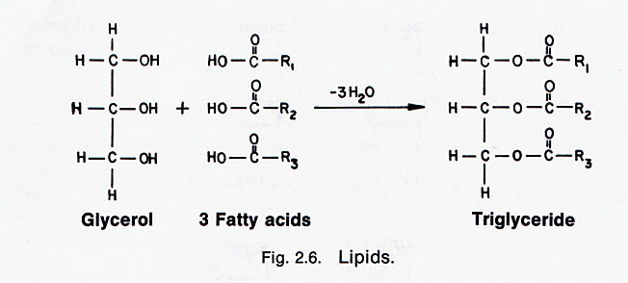**- Lipids are insoluble in water, but soluble in fat or organic solvents (ether, chloroform, benzene, acetone).**

**- They contain many nonpolar C—C and C—H bonds and few polar bonds resulting in their water insolubility.**

**- They are widely distributed in nature both in plants and in animals.**

**- Lipids include fats, butter, ghee, lard, tallow, steroids. Also vegetable oils such as olive oil, corn oil, soybean oil, sun flower oil, cotton feed oil, fish oil waxes and related compounds.**

**Biological Importance of Lipids:**

* Source of energy.
* Carrier of vitamins.(A,D,E,K)
* Structural function.(phospholipids and spingolipids Inter in the construction of the plant cell wall)
* Protective coating. Such as waxes that important as Aprotective cover the tissues of plants and some animals.
* **Fat & Health**

**- Unsaturated triacylglycerols (omega-3 fatty acids from fish) lower the risk of heart disease by decreasing the level of cholesterol in the blood.**

**- However, if the double bond of the unsaturated triacylglycerol is trans, the beneficial effect is lost.**

**- Trans fats, which are primarily synthesized instead of naturally occurring, act like saturated fats and increase the cholesterol levels in the blood.**

**Lipids can be categorized as:**

1. **Hydrolyzable lipids can be converted into small molecules by aqueous hydrolysis.**

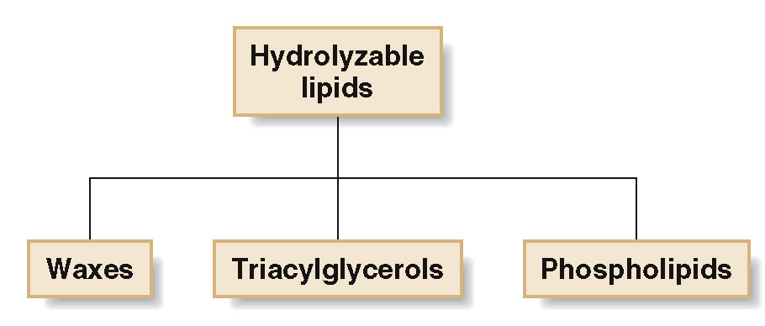



**Nonhydrolyzable lipids cannot be cleaved into smaller molecules by aqueous hydrolysis.**

